Acoustic Analysis Example

Showing

Waveform, Spectrogram & Power

Graphs

with application(s) to

Route 91 Harvest Festival
October 1, 2017
Shooting
Las Vegas, Nevada

Ver 0.0.1

Saturday, June 1, 2019

Richard L. Mullins

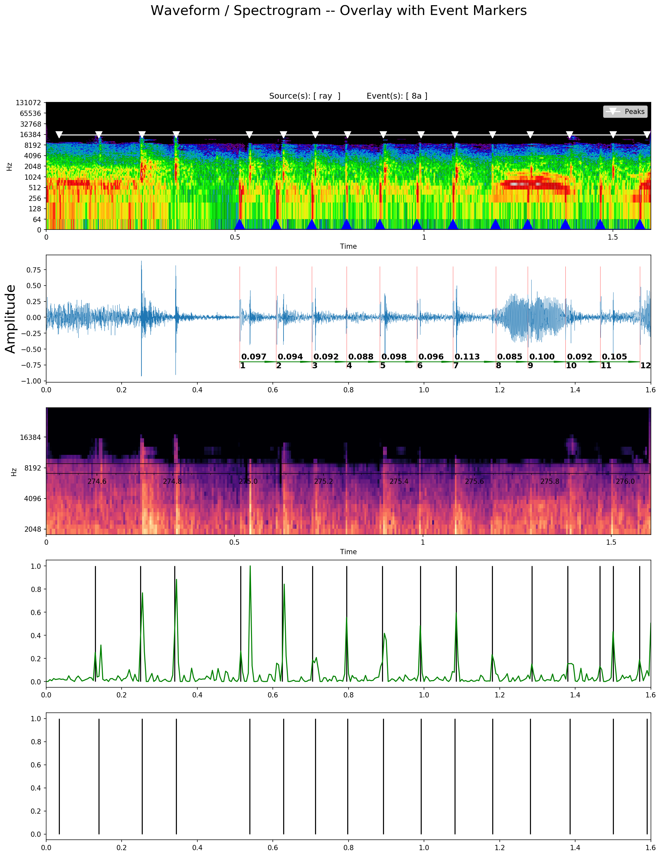
Possible Sonic Events
Muzzle Blast(s)
Background Noise
Spectrogram
Waveform
Power (db²) Spectrogram
Onsets(s)
Interesting Events
(white triangles on Spectrogram)
Muzzle Number
Delta (seconds)

Introduction
Enclosed are five graphs of a 1.6 second audio segment from the Raymond Page video recorded on Oct. 1, 2017 at the Route 91 Venue. Each of these graphs was produced by myself with the aid of the Python programming language and it’s libraries including librosa, numpy, scipy, pandas and a few others. Each graph has a few explanatory text additions manually added with LibreOffice.
The graphs presented are one of many steps applied in a typical analysis of audio. In this particular instance, I am at the point of determining which “events” are likely the result of a direct-path sound recording of the sonic wave created by a supersonic bullet passing within recording distance. Here the video was recorded near the north west area of the venue along Las Vegas Blvd.
This analysis focuses on volley 8 of gunfire, and in particular the first few moments of the first group of bullets.
In the grand scheme of things often one hundred or more graphs are used in the analysis of each segment of audio down to a single shot. If multiple shots (like this case) are presented at once sometimes fewer graphs may be employed. So one hundred graphs per volley, 10 volleys per video, 30 plus videos produces a LOT of graphs, which is why exacting details of audio forensics can take considerable time (even with computer automation.)

Theory
For a quick intro to the theory and practical implications of gunshot acoustics I recommend:
- Deciphering Gunshot Recordings, Robert C. Maher and Steven R. Shaw
- On Acoustic Gunshot Localization Systems, Ramos et. al.

Notes
- As audio goes the Raymond Page recording is about middle of the road in terms of signal to noise ratio, quality of recording, and overall information content. The movement of the recording person does pose some problems forensically, but the length and number of volleys captured compensates.
- With the aid of frequency based analysis, the sonic shock wave of the supersonic projectile is much more attainable in both high and low noise environments. These wavefronts have been extracted from nearly every audio at every location, even when the bullet path was 1,200 ft distant.

Waveform Plot (Time Domain Analysis)
This amplitude vs. time graph is quite often the first type of information viewed by investigators when examining audio. Nearly every audio processing software accomodates this view of the audio. From this graph we observe that there are at least 24 prominent excursions outside the baseline noise. From prior analysis I have classified 12 of these 24 events as direct-path muzzle blast events. These are marked with a singular vertical red line. Also marked on this graph are the differences in time between these muzzle events, ranging from a low of 0.088 seconds to a maximum of 0.113 seconds (88 and 113 millisecond). I refer to these as “deltas”.

Spectrogram Plot (Frequency Domain Analysis)
This graph plots frequency (logarithmic scale) on the y axis and time on the x axis. Frequencies are calculated with algorithms based on Fast Fourier Transforms. The “intensity” of the frequency is shown via color where the scale goes from least intense (dark colors) to more intense (lighter colors). This type of graph is sometimes available in audio processing software like audacity. When not using my own algorithms I favor Sonic Visualiser from Queen Mary University of London. Each software tool has it’s own advantages and limitations.
The Spectrogram shown is augmented with blue markers on the bottom indicating sounds isolated as muzzle blasts, and white markers on the top indicating potential sonic shock wave(s). Each set of markers is created with proprietary algorithm(s) and manually reviewed for relevence.
From the Spectrogram it’s clear that the 24 sounds visualized from the waveform fall into two categories, those centered near a frequency of 256 Hz (muzzle blasts) and those centered near a frequency of 1,800 Hz (sonic shock waves). These frequencies, their overlap, and separation are consistent with the theory of gunshot acoustics.
Spectrograms offer a wealth of information that is not readily accessed with a simple waveform. For example, in this audio, the second potential sonic blast, buried in the background noise is difficult to ascertain without the use of a frequency based analysis.
Note that with this Spectrogram it immediately becomes clear that the sonic shock-wave usually precedes the corresponding muzzle blast. This is consistent with gunshot acoustic theory. The difference in time of arrival between the sonic and muzzle is often referred to as “lag” and carries with it much information about the source and location of both the shooter and the recording device. This sample has a “lag” time on the order of 0.3 seconds. To put another way, this recorder hears the sonic shock wave created by a supersonic bullet nearly a 1/3 of second before the corresponding muzzle blast arrives. In this example two sonic waves are indicated before the first muzzle blast is heard.
The distance to the shooter can be approximated from this “lag” (provided the distance to the bullet path can also be accurately estimated), but is beyond the scope of this short paper. That is, the math is complicated (as in many equations etc.). Put another way, it it not possible to accurately estimate distance to shooter unless two or more variables are known. (1) “lag” and (2) “miss distance” (distance to bullet trajectory) would suffice.

Power (db2) Plot (Estimation of Instant Loudness)
Often it is necessary to get a handle on the “intensity” of a sound to make further characterizations and classifications. This is particularly true for “percussive” sounds (like explosions, drums, glass breaking etc.). The power plot used, a logarithmic plot of “intensity” squared (measured in decibels – dB) is a good proxy for power. This graph is augmented with times relative to the start of the whole audio from which this segment was extracted as a dark set of annotations in the middle of the graph. Some later versions will use a lighter color as to be more visible.
In the example given it can be observed that:
- The background noise in the first part of the segment is not that loud relative to the gunshot sounds.
- Around 0.4 seconds and prior to the first muzzle blast, the intensity of the background noise diminished. This could be the result of automatic gain circuitry in the recording device or just the “natural” intensity of the sounds.
- The 3rd, 4th, and 5th proposed sonic blasts are recorded as substantially more intense than others. In particular the 3rd proposed sonic blast has something else going on. This intensity as visualized in the regular Spectrogram, occurs near the same frequency as the direct sonic blast. Possibly the bullet passed very close or passed through a very stiff medium. More analysis is required to determine which.
- The energy or power of the sonic blasts are very broadband, that is the energy is spread across a large spectrum of frequencies, where as the muzzle blasts in this example are more restricted.
- The intensity of the sound spanning 1.2 to 1.4 seconds of this segment is generally about the same intensity as both the sonic blast and muzzle blasts occurring during this region. This sound on first blush is likely to be a vocalization.

Onset(s) Plot
This graph shows the strength of the spectral flux onset detection algorithm. Larger values indicate regions of the audio which likely include significant changes to the frequencies, power and spectral contrast of surrounding events. Local maxima are marked with vertical lines.

Events of Interest Plot
This plot shows points of interest after eliminating non-overlapping muzzle blast regions from consideration. The results are marked with vertical lines and also plotted on the spectrogram as white triangles.

